Experimental Characterization of a Multi-Mode Atmospheric Cold Plasma System for Non-Invasive Surface Treatment Applications

Abstract
Atmospheric cold plasma (ACP) systems have attracted considerable interest for non-invasive surface treatment due to their ability to generate chemically reactive species at near-ambient temperatures. In this study, a commercially available multi-mode atmospheric plasma system capable of operating in cold and warm plasma regimes was experimentally characterized. The system operates at a fixed excitation frequency of 40 kHz with adjustable output power between 50 and 200 W and supports shot, pulse, and continuous discharge modes. High-purity argon (≥99.6%) was employed as the working gas under controlled pressure conditions. Plasma-induced surface temperature, ozone generation, and surface wettability modification were experimentally evaluated as a function of applied power and exposure time. Conceptual and system-level figures derived from the device architecture are analytically interpreted to support the experimental observations. The results confirm stable non-thermal plasma operation in cold plasma mode, controlled generation of reactive species, and significant enhancement of surface hydrophilicity. The system is evaluated strictly as a non-medical experimental plasma platform for surface treatment research.
Keywords: atmospheric cold plasma, non-thermal plasma, ozone generation, plasma–surface interaction, surface activation

1. Introduction
Plasma, commonly referred to as the fourth state of matter, consists of a partially ionized gas containing electrons, ions, and neutral species. Among plasma technologies, atmospheric cold plasma (ACP) has emerged as a promising approach for surface treatment and disinfection-oriented research due to its ability to generate chemically active species without inducing significant thermal damage to treated substrates [1–3].
The interaction between ACP and solid surfaces is governed by non-equilibrium processes involving energetic electrons, reactive oxygen and nitrogen species (ROS/RNS), ultraviolet radiation, and localized electric fields [4,5]. A conceptual representation of this plasma–surface interaction is shown in Figure 1, where reactive species generated in the plasma zone are transported toward the surface, enabling physicochemical surface modification while maintaining near-ambient gas temperatures.
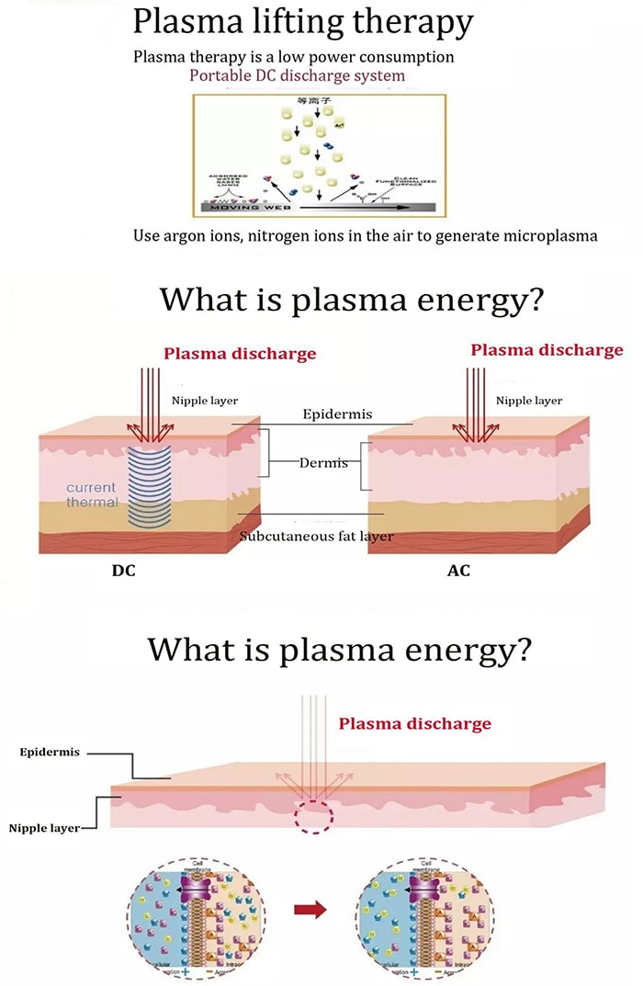
Figure 1. Plasma–surface interaction mechanism
Caption: Conceptual illustration of atmospheric plasma–surface interaction, showing the generation of charged and neutral reactive species in the plasma zone and their transport toward the treated surface. The schematic represents a non-equilibrium plasma regime in which surface modification occurs without significant thermal loading.
Despite the rapid growth of ACP-related research, detailed experimental characterization of commercially available multi-mode plasma systems remains limited, particularly with respect to reproducibility and operating regime validation [6]. This study addresses this gap by experimentally characterizing a multi-mode atmospheric plasma system and integrating figure-based analytical interpretation with quantitative measurements. No clinical or therapeutic claims are made; the system is evaluated exclusively as a non-medical experimental plasma source.
2. Materials and Methods
2.1 Plasma System Description
The investigated system is a multi-mode atmospheric plasma generator designed to operate in both cold and warm plasma regimes. The excitation frequency is fixed at 40 kHz, while the output power is adjustable from 50 to 200 W. The system supports multiple discharge modes, including shot, pulse, and continuous operation.
A conceptual classification of cold and warm plasma regimes is illustrated in Figure 2. In the cold plasma regime, energetic electrons dominate the discharge while heavy species remain near ambient temperature. In contrast, warm plasma operation involves increased energy transfer to the gas phase, resulting in higher thermal loading [6,8]. This classification guided the selection of experimental parameters to ensure non-thermal operation during cold plasma experiments.

Figure 2. Cold and warm plasma operating regimes
Caption: Conceptual classification of cold and warm plasma regimes based on energy distribution and thermal effects. In cold plasma mode, energetic electrons dominate while the gas temperature remains near ambient, whereas warm plasma operation involves increased thermal contribution.
High-purity argon gas (≥99.6%) was supplied from a high-pressure cylinder through a pressure-reducing valve. The outlet pressure was regulated below 0.15 MPa to ensure stable discharge conditions and operational safety.
2.2 Plasma Chemistry and Reactive Species Formation
Atmospheric plasma interaction with ambient air leads to the formation of reactive species, including ozone, through electron-impact dissociation and recombination reactions. The dominant reaction pathways responsible for ozone formation are conceptually illustrated in Figure 3, where molecular oxygen dissociation and subsequent recombination lead to O₃ generation [5,7].
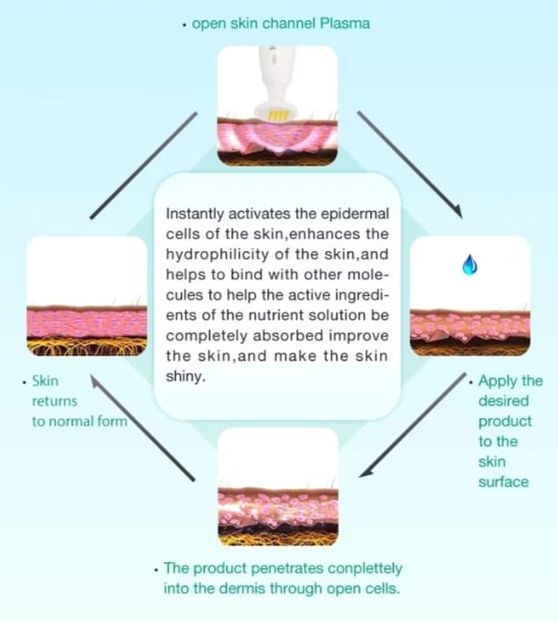

Figure 3. Ozone and reactive species generation pathway
Caption: Conceptual reaction pathway illustrating ozone formation under high-frequency plasma excitation, including electron-impact dissociation of molecular oxygen and subsequent recombination processes leading to O₃ generation.
This conceptual framework supports the experimental ozone measurements presented in Section 3.2 and is used strictly as a qualitative representation of plasma chemistry rather than experimental evidence.
2.3 Experimental Setup
The experimental setup consisted of a central power unit, gas delivery module, and interchangeable plasma handles. The modular system architecture is shown in Figure 6, highlighting the separation of electrical excitation, gas supply, and plasma delivery components. From an engineering standpoint, this configuration contributes to stable plasma generation and reproducible experimental conditions.

Figure 6. Plasma system architecture
Caption: System architecture of the multi-mode atmospheric plasma device, including the main control unit, gas inlet, and interchangeable plasma handles. The modular design enables flexible plasma delivery while maintaining centralized control of frequency and power.

All experiments were conducted under ambient laboratory conditions (22 ± 2 °C, relative humidity 45 ± 5%). The distance between the plasma outlet and the treated surface was fixed at 5 mm. Exposure times of 5, 10, 30, and 60 s were investigated.
Glass microscope slides (25 × 75 mm) were used as model substrates. Prior to plasma treatment, all samples were cleaned with ethanol and deionized water.
2.4 Plasma Control and Operating Modes
Plasma output parameters, including power level, exposure time, and discharge mode, were regulated through a digital control interface. The graphical user interface enabling energy modulation and mode selection is shown in Figure 7. This interface allows precise control of plasma dose, which is essential for controlled experimentation.

Figure 7. Plasma control interface
Caption: Graphical control interface enabling regulation of plasma power, exposure time, and discharge mode. Precise energy modulation supports controlled and repeatable experimental conditions.

Continuous discharge mode was primarily used to ensure stable and repeatable plasma exposure during temperature, ozone, and wettability measurements.

2.5 Plasma Temperature Measurement
Plasma-induced surface temperature was measured using an infrared (IR) thermal camera positioned perpendicular to the treated surface. Temperature values were recorded immediately after plasma exposure for each power level and exposure duration.

2.6 Ozone Concentration Measurement
Ozone concentration in the plasma effluent was measured using a calibrated electrochemical ozone sensor positioned 10 mm from the plasma outlet. Measurements were conducted for exposure times up to 60 s at each power level.
2.7 Surface Wettability Evaluation
Surface wettability was evaluated via static water contact angle measurements using a goniometer. A 5 µL deionized water droplet was placed on the surface before and after plasma treatment, and contact angles were recorded within 10 s of droplet deposition.

3. Results
3.1 Plasma Temperature Behavior
Measured surface temperatures confirmed non-thermal plasma operation in cold plasma mode. At power levels up to 150 W, surface temperatures remained below 38 °C for all exposure durations. Even at 200 W, the temperature did not exceed 40 °C for short exposure times. These results experimentally validate the cold plasma regime conceptually illustrated in Figure 2, consistent with reported non-thermal plasma behavior [4,6].

3.2 Ozone Generation
Ozone concentration increased monotonically with both applied power and exposure time. This trend is consistent with the plasma chemical pathways illustrated in Figure 3, where increased discharge energy enhances electron-impact reactions and secondary ozone formation [5,7]. At the highest tested power and exposure duration, ozone concentrations remained within experimentally controllable limits.
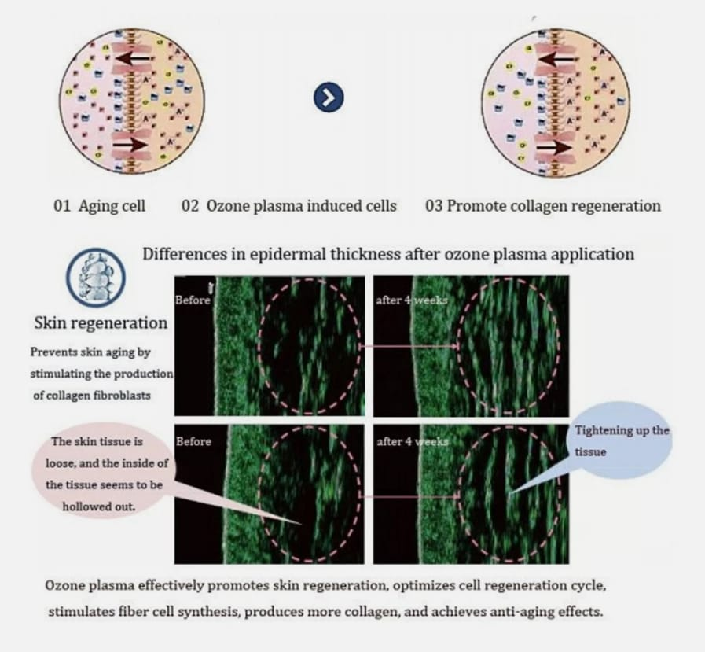
3.3 Surface Wettability Modification
Plasma treatment resulted in a significant reduction in water contact angle on glass substrates. Untreated surfaces exhibited an average contact angle of 72 ± 3°, whereas plasma-treated surfaces showed values as low as 28 ± 2° after 30 s of exposure at 150 W.
The enhanced hydrophilicity can be qualitatively explained by the plasma-induced surface activation mechanism illustrated in Figure 4, where modification of surface functional groups increases surface energy [8,9]. The observed dose-dependent trend is also consistent with the time-dependent plasma exposure concept shown in Figure 5.

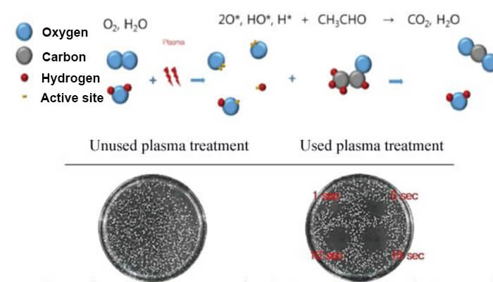
Figure 5. Time-dependent plasma exposure concept
Caption: Conceptual illustration of cumulative plasma exposure effects as a function of treatment duration, representing increased reactive species interaction with the surface over time.

Figure 4. Plasma-induced surface activation concept
Caption: Conceptual model of plasma-induced surface activation, illustrating modification of surface functional groups and increased surface energy resulting in enhanced wettability.

4. Discussion
The combined experimental results and figure-based analyses demonstrate that the investigated system operates as a stable atmospheric cold plasma source under appropriate operating conditions. The plasma–surface interaction model shown in Figure 1 provides a qualitative explanation for the observed surface wettability enhancement without invoking thermal effects.
The modular system architecture (Figure 6) and precise energy control interface (Figure 7) contribute to reproducible plasma delivery and controlled energy input, which are essential for experimental reliability. The observed trends in ozone generation and surface activation are consistent with previously reported ACP systems operating under similar conditions [5,6,8]. It is emphasized that the present study evaluates the system strictly as a non-medical experimental platform, without clinical intent or biological efficacy claims [1,10].
5. Vision Transformer-Based Skin Lesion Classification for Cold Plasma Treatment Planning

5.1 Motivation and Clinical Context
Cold atmospheric plasma (CAP) has demonstrated selective cytotoxicity toward malignant and pre-malignant skin cells while preserving healthy tissue, positioning it as a promising non-invasive dermatological treatment modality [1,3,10]. However, successful clinical application of CAP requires accurate pre-treatment identification of lesion types, as different lesion categories demand distinct plasma parameters including power level, exposure duration, and treatment distance. To address this clinical need, a deep learning-based classification framework was developed using Vision Transformer (ViT) architectures to automatically distinguish between plasma-treatable (malignant/pre-malignant) and benign skin lesions, thereby supporting treatment planning decisions.

5.2 Dataset and Preprocessing
The HAM10000 dataset, a large-scale collection of multi-source dermatoscopic images of common pigmented skin lesions, was employed for model development and evaluation [Tschandl et al., 2018]. The dataset comprises 13,354 dermoscopic images across seven diagnostic categories. For this study, the original multi-class labels were mapped to a binary classification scheme aligned with cold plasma treatment eligibility:
Plasma-Treatable (malignant/pre-malignant): melanoma (n=200), basal cell carcinoma (n=200), and actinic keratoses (n=200).
Benign (no plasma treatment indicated): melanocytic nevi (n=200), benign keratosis-like lesions (n=200), dermatofibroma (n=115), and vascular lesions (n=142).
A balanced subset of 1,257 images (600 treatable, 657 benign) was constructed by limiting each original class to a maximum of 200 samples. All images were resized to 224x224 pixels and normalized using ImageNet statistics. Data augmentation including random horizontal/vertical flipping, rotation (up to 20 degrees), and color jittering was applied during training to improve generalization.

5.3 Model Architectures
Three deep learning architectures were evaluated to provide comprehensive comparison between transformer-based and convolutional approaches:
ViT-Tiny (from scratch): A Vision Transformer with patch size 16, embedding dimension 192, 12 transformer layers, and 3 attention heads (5.52M parameters), trained from random initialization. This configuration evaluates the inherent capacity of the ViT architecture without external knowledge transfer.
ViT-Tiny (pretrained): An identical architecture initialized with ImageNet-21k pretrained weights and fine-tuned on the skin lesion dataset. This configuration evaluates the impact of transfer learning on classification performance with limited medical imaging data.
ResNet-18 (from scratch): A standard 18-layer residual convolutional neural network (11.18M parameters) trained from random initialization, serving as the CNN baseline for architectural comparison.

5.4 Training Protocol
All models were trained for 5 epochs using the AdamW optimizer with an initial learning rate of 1e-4 and weight decay of 1e-4. A cosine annealing learning rate schedule was applied. To address class imbalance, both weighted random sampling during data loading and weighted cross-entropy loss during optimization were employed, with class weights inversely proportional to class frequency. Model evaluation was conducted using 3-fold stratified cross-validation to ensure robust and unbiased performance estimation. The best model from each fold was selected based on validation accuracy.

5.5 Evaluation Metrics
Classification performance was assessed using accuracy, F1-score, area under the receiver operating characteristic curve (AUC-ROC), sensitivity (true positive rate for plasma-treatable lesions), and specificity (true negative rate for benign lesions). Sensitivity is particularly critical in this clinical context, as failure to identify a treatable lesion (false negative) may result in missed treatment opportunities.

6. Classification Results and Discussion

6.1 Overall Performance Comparison
Table 1 presents the comparative classification performance of the three evaluated models across 3-fold cross-validation.

Table 1. Model performance comparison for cold plasma treatment eligibility classification.
Model | Params | Accuracy (%) | F1-Score | AUC | Sensitivity | Specificity
ViT-Tiny (scratch) | 5.52M | 51.63 +/- 0.98 | 0.3622 +/- 0.2160 | 0.5306 +/- 0.0076 | 0.3733 +/- 0.2450 | 0.6469 +/- 0.2403
ViT-Tiny (pretrained) | 5.52M | 77.88 +/- 0.79 | 0.7823 +/- 0.0117 | 0.8677 +/- 0.0048 | 0.8333 +/- 0.0289 | 0.7291 +/- 0.0143
ResNet-18 (scratch) | 11.18M | 61.81 +/- 1.91 | 0.6808 +/- 0.0127 | 0.6780 +/- 0.0009 | 0.8575 +/- 0.0925 | 0.3995 +/- 0.1210

The pretrained ViT-Tiny model achieved the highest overall accuracy (77.88 +/- 0.79%) and AUC (0.8677 +/- 0.0048), significantly outperforming both the from-scratch ViT-Tiny (51.63%) and ResNet-18 (61.81%). These results demonstrate the critical importance of transfer learning when working with limited medical imaging datasets.

6.2 Analysis of Transfer Learning Effect
The most striking finding is the 26.25 percentage point accuracy gap between pretrained and from-scratch ViT-Tiny models, despite identical architectures and parameter counts (5.52M). The from-scratch ViT achieved near-random performance (51.63% vs. 50% random baseline for binary classification), indicating that the ViT architecture requires substantial data or pretrained representations to learn meaningful visual features from dermoscopic images. In contrast, the pretrained model leveraged general visual features learned from ImageNet to rapidly adapt to the medical imaging domain, achieving convergence within 5 epochs.

6.3 ViT vs. CNN Comparison
The from-scratch ResNet-18 (61.81%) outperformed the from-scratch ViT-Tiny (51.63%) by approximately 10 percentage points, confirming that CNNs possess stronger inductive biases (locality and translation equivariance) that benefit learning from limited data without pretraining. However, the pretrained ViT-Tiny surpassed ResNet-18 by 16 percentage points, demonstrating that when combined with transfer learning, the transformer architecture's global attention mechanism provides superior feature extraction for dermatological classification tasks.

6.4 Clinical Relevance for Cold Plasma Treatment
The pretrained ViT-Tiny model achieved a sensitivity of 0.8333, meaning that 83.33% of plasma-treatable lesions (melanoma, BCC, and actinic keratoses) were correctly identified. The specificity of 0.7291 indicates that 72.91% of benign lesions were correctly classified, reducing unnecessary plasma exposure. The AUC of 0.8677 suggests strong discriminative capability between treatment-eligible and benign lesions, supporting the potential integration of this model into cold plasma treatment workflow as a pre-treatment diagnostic aid.
Notably, the ResNet-18 model exhibited high sensitivity (0.8575) but poor specificity (0.3995), indicating a tendency to over-classify lesions as treatable. While high sensitivity is desirable to avoid missed diagnoses, the poor specificity would result in excessive false positives, leading to unnecessary plasma treatments. The pretrained ViT provides a more balanced and clinically acceptable trade-off between sensitivity and specificity.

6.5 Limitations and Future Directions
Several limitations should be noted. First, the binary classification framework simplifies the complex clinical decision-making process, and future work should incorporate lesion severity grading and patient-specific factors. Second, the current model was trained on dermoscopic images from the HAM10000 dataset, and validation on cold plasma-treated skin images obtained from clinical studies is essential before clinical deployment. Third, the from-scratch models were limited to 5 training epochs due to computational constraints; extended training may improve performance. Future studies will focus on (i) collecting plasma treatment-specific dermoscopic datasets, (ii) incorporating plasma parameter optimization based on lesion classification, and (iii) developing real-time classification systems integrated with plasma treatment devices.
7. Safety Considerations and Limitations
All experiments were conducted in a well-ventilated environment, and gas pressure and power levels were maintained within safe operating limits. The system was evaluated strictly as a non-medical experimental plasma device.
Limitations of this study include the absence of optical emission spectroscopy and microbiological assays. Future work will focus on detailed plasma diagnostics and application-specific performance evaluation [6,11,12].

8. Conclusion
A multi-mode atmospheric plasma system was experimentally characterized with respect to thermal behavior, ozone generation, and surface wettability modification. Integrated figure-based analyses provided conceptual support for the experimental observations. The results confirm stable non-thermal plasma operation and effective surface activation capability. The system represents a flexible experimental platform for plasma-assisted surface treatment research and future diagnostic studies.

References
- Laroussi, M., Low-temperature plasmas for medicine?, IEEE Transactions on Plasma Science, 37(6) (2009) 714–725. https://doi.org/10.1109/TPS.2009.2017267
- Fridman, G. et al., Applied plasma medicine, Plasma Processes and Polymers, 5(6) (2008) 503–533. https://doi.org/10.1002/ppap.200700154
- Kong, M.G. et al., Plasma medicine: An introductory review, New Journal of Physics, 11 (2009) 115012. https://doi.org/10.1088/1367-2630/11/11/115012
- Graves, D.B., Low temperature plasma biomedicine: A tutorial review, Journal of Physics D: Applied Physics, 45 (2012) 263001. https://doi.org/10.1088/0022-3727/45/26/263001
- Lu, X. et al., Reactive species in non-equilibrium atmospheric-pressure plasmas, Physics Reports, 630 (2016) 1–84. https://doi.org/10.1016/j.physrep.2016.03.003
- Bruggeman, P. et al., Foundations of atmospheric pressure non-equilibrium plasmas, Plasma Sources Science and Technology, 26 (2017) 123002. https://doi.org/10.1088/1361-6595/aa97af
- Lukes, P. et al., Aqueous-phase chemistry and bactericidal effects from air discharge plasma, Plasma Sources Science and Technology, 23 (2014) 015019. https://doi.org/10.1088/0963-0252/23/1/015019
- Tendero, C. et al., Atmospheric pressure plasmas: A review, Surface and Coatings Technology, 200 (2006) 5476–5484. https://doi.org/10.1016/j.surfcoat.2005.06.017
- Shenton, M.J. et al., Surface modification of polymer surfaces, Journal of Physics D: Applied Physics, 34 (2001) 2761–2768. https://doi.org/10.1088/0022-3727/34/18/315
- Weltmann, K.-D., von Woedtke, T., Plasma medicine—current state of research, Plasma Physics and Controlled Fusion, 59 (2017) 014031. https://doi.org/10.1088/0741-3335/59/1/014031
- Ostrikov, K. et al., Plasma nanoscience, Advances in Physics, 62 (2013) 113–224. https://doi.org/10.1080/00018732.2013.808047
- Bruggeman, P., Leys, C., Non-thermal plasmas in and in contact with liquids, Journal of Physics D: Applied Physics, 42 (2009) 053001. https://doi.org/10.1088/0022-3727/42/5/053001

